**Self referrals**

URL on the website could look like this.

I suggest that the name/demographic info comes first rather than details of the condition.

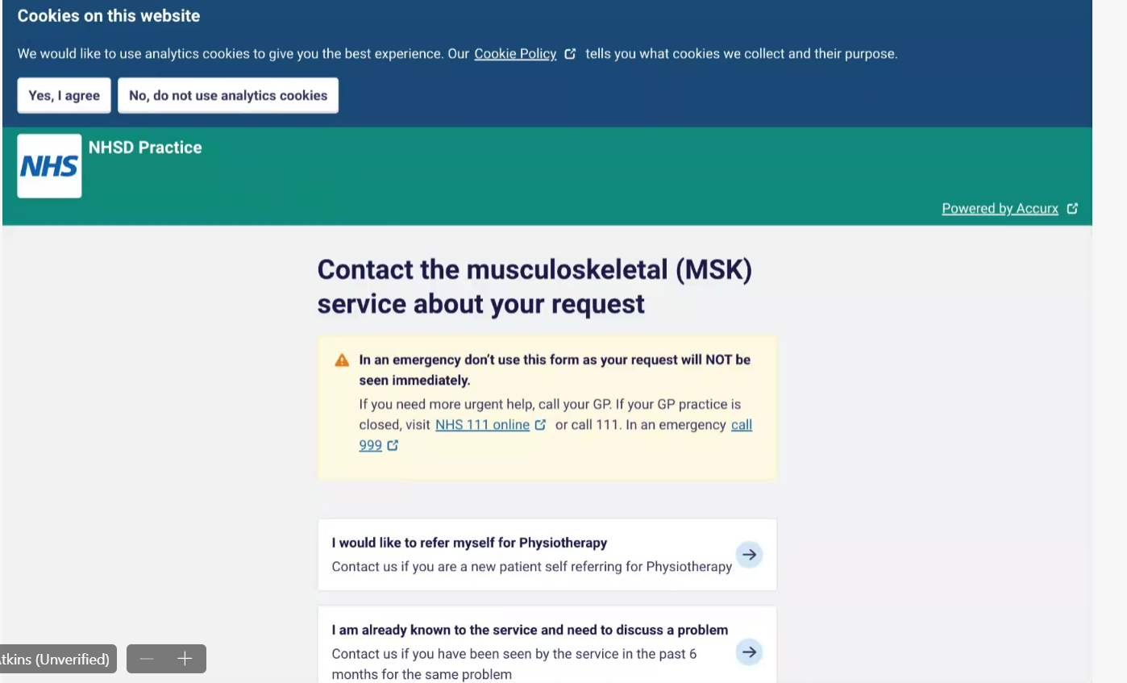

* I would like to refer myself for Falls Prevention
* I am already known to the service and need to discuss a problem / provide an update on my condition.
* I have a question about an upcoming appointment
* I would like to see self management advice.

**Falls Prevention self-referral form**

**DO NOT USE THIS FORM IF YOU:**

**are aged 64 and under - Please speak to your GP for advice.**

**Please describe the problem**

TEXT BOX

**When did your symptoms/problem start?**

TEXT BOX

**Have your symptoms got better, worse, or stayed the same since they started?**

Better

Worse

Stayed the same

**How many times have you fallen in the last 12 month?**

TEXT BOX

**Please describe what you were doing when you fell (eg I stood up from sitting and fell / I was in the kitchen and turned around and lost my balance etc)**

TEXT BOX

**Have you had any treatment for this problem recently or in the past? (Please include both self-treatment or professional and whether this helped the problem.)**

TEXT BOX

**Have you seen your GP about this problem?**

YES NO

**What outcome are you hoping for after seeing the falls prevention team?**

TEXT BOX

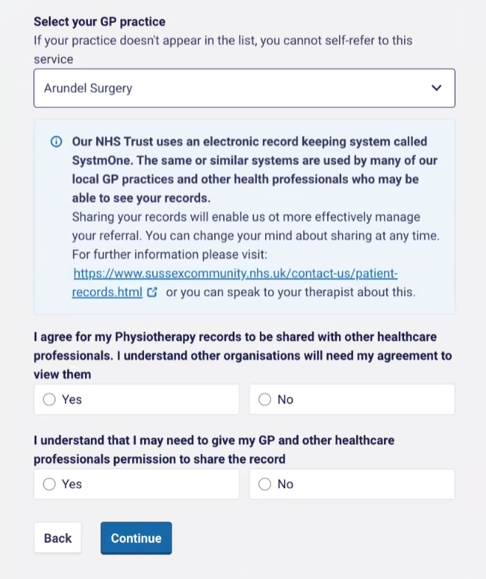

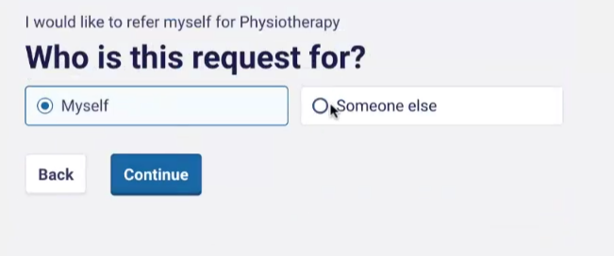

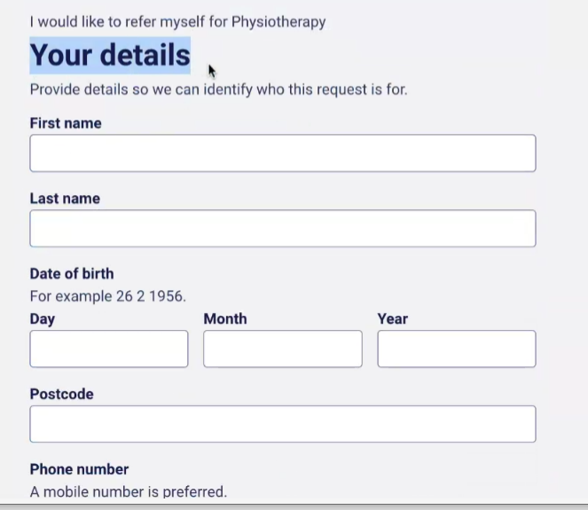

Can save to record or flag as unmatched

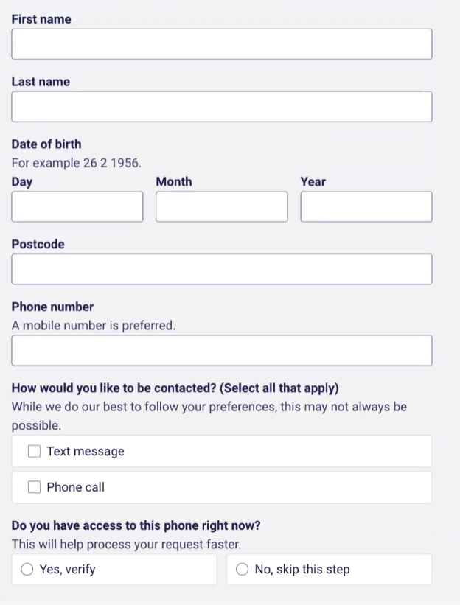

If ticking completing for someone else:

**Did you get consent from the patient to make this referral?**

YES NO

If no please give details

**Do you have POA for the patient?**

YES NO